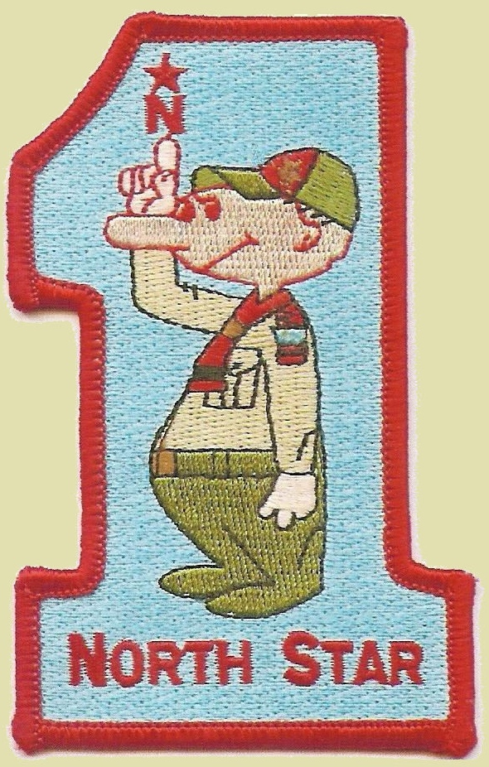
North Star District
Questionnaire for
Outing Ideas
PURPOSE:
This form is intended to help units share their experiences with different outing activities and venues. Our goal as a district is to have each unit share their “favorite activities” with the hope that Pack Committees, Patrol Leader Councils, or Crew Executive Committees can use these ideas to plan future events.
There is no preference for certain budget ranges or distances from the District. Instead it is to best represent your unit’s experiences.
INSTRUCTIONS:
Please complete this form and email a completed copy to news@cacnorthstar.org for District Vice Chair for Communication Cheryl Bilsland and copy Jeff Heck at jheck@cacnorthstar.org as the custodian of this page. You are encouraged to fill this out on a computer for legibility and send it PDF for ease of reading, if possible. If those don’t work, send it how you can. We’ll figure it out.
Please do not feel like you need to know all the information requested. This form is not intended to replace research that youth could be doing. It is intended to expand the horizons of thought. Provide what information is readily at hand. Websites and emails are particularly valuable for reference, especially if they are not easy to find through Google.
The term “outfitter” generally refers to a company providing equipment or support services to an adventure, such as canoeing outfitter. This term will be used generically here to refer to any outfitter, supplier, or vendor providing any type of support, instruction, equipment sales or rental, guides, or ticket sales. If multiple companies divide up these responsibilities, please provide additional contact information on additional blank pages.

Descriptive Title for Activity: _____________________________________________________
Venue Name & Address: _________________________________________________________
Travel time from center of District (about 96th and Michigan Rd): _____ hours ____ minutes
Description of Activity or Activities Undertaken at Venue, including number of nights away:
______________________________________________________________________________
______________________________________________________________________________
______________________________________________________________________________
If overnight, what type of sleeping accommodations? Where? Tents? Cabins? _______________
______________________________________________________________________________
Age of scouts participating? ______________ Too young/old/just right? _______________
Number of adults & scouts ___________ Sufficient number of adults? _____________
BSA or third-party training needed to complete outing? _________________________________
Critique of Activity (Stop/Start/Continue) and Outfitter: _________________________________
______________________________________________________________________________
______________________________________________________________________________
Outfitter’s Name: ________________________________ Website: ______________________
Outfitter’s Address: _____________________________________________________________
Outfitter’s Phone: _______________________________________________________________
What lessons did you learn from this outing that you would use to change or improve the activity, if your unit were to do the activity again? Different time of year? Different outfitter? Different equipment selection? Different age group taken? _______________________________________
______________________________________________________________________________
______________________________________________________________________________
______________________________________________________________________________
______________________________________________________________________________
______________________________________________________________________________
Cost per scout for entire trip, including travel, lodging, activities, and gear? $________________
What changes could be made to lower the price? _______________________________________
______________________________________________________________________________
______________________________________________________________________________
What additional services, gear, or activities that you did not purchase but which might enhance the experience if you were to participate again in the future? _________________________________
______________________________________________________________________________
How did you handle meals? _______________________________________________________
If food provided by outfitter or outside unit, describe arrangements: _______________________
______________________________________________________________________________
Would you recommend this for a similar unit? ____________ Why? _______________________
______________________________________________________________________________
If any aspect of the outing were changed, what change would cause you to not to participate in this outing in the future? Why is that change significant to you? ______________________________
______________________________________________________________________________
______________________________________________________________________________
Other comments not addressed in the previous questions?

